**ASSIGNMENT OF PHP: MySQL (PDO LIB)**

**QUESTION 1: Create a form to insert First name, Last name, email id and contact no. Email id must be unique across the table. Validation must on DB and code level.**

**ANSWER 1:**

**HTML CODE :**

**<html lang="en">**

**<head>**

**<meta charset="UTF-8">**

**<meta name="viewport" content="width=device-width, initial-scale=1.0">**

**<title>Document</title>**

**<link rel="stylesheet" href="https://stackpath.bootstrapcdn.com/bootstrap/4.4.1/css/bootstrap.min.css" integrity="sha384-Vkoo8x4CGsO3+Hhxv8T/Q5PaXtkKtu6ug5TOeNV6gBiFeWPGFN9MuhOf23Q9Ifjh" crossorigin="anonymous">**

**<script src="https://code.jquery.com/jquery-3.4.1.slim.min.js" integrity="sha384-J6qa4849blE2+poT4WnyKhv5vZF5SrPo0iEjwBvKU7imGFAV0wwj1yYfoRSJoZ+n" crossorigin="anonymous"></script>**

**<script src="https://cdn.jsdelivr.net/npm/popper.js@1.16.0/dist/umd/popper.min.js" integrity="sha384-Q6E9RHvbIyZFJoft+2mJbHaEWldlvI9IOYy5n3zV9zzTtmI3UksdQRVvoxMfooAo" crossorigin="anonymous"></script>**

**<script src="https://stackpath.bootstrapcdn.com/bootstrap/4.4.1/js/bootstrap.min.js" integrity="sha384-wfSDF2E50Y2D1uUdj0O3uMBJnjuUD4Ih7YwaYd1iqfktj0Uod8GCExl3Og8ifwB6" crossorigin="anonymous"></script>**

**</head>**

**<body>**

**<div class="jumbotron">**

**<h1>FORM</h1>**

**</div>**

**<form name="formnew" method="POST" action="formnew.php">**

**<div class="row">**

**<div class="col">**

**NAME<input type="text" class="form-control" name="fn" placeholder="First name">**

**</div>**

**<div class="col">**

**LAST<input type="text" class="form-control" name="ln" placeholder="Last name">**

**</div>**

**</div>**

**<div class="form-group">**

**<label for="exampleInputEmail1">Email address</label>**

**<input type="email" class="form-control" id="exampleInputEmail1" name="em" aria-describedby="emailHelp">**

**<small id="emailHelp" class="form-text text-muted">We'll never share your email with anyone else.</small>**

**</div>**

**<div class="form-group">**

**<label for="formGroupExampleInput">Contacts</label>**

**<input type="text" class="form-control" name="cont" id="formGroupExampleInput" placeholder="Enter your number">**

**</div>**

**<button type="submit" class="btn btn-primary">Submit</button>**

**</form>**

**</body>**

**</html>**

**PHP CODE :**

**<?php**

**//ini_set('display_errors', 1);**

**$name=$_REQUEST["fn"];**

**$last=$_REQUEST["ln"];**

**$email=$_REQUEST["em"];**

**$contact=$_REQUEST["cont"];**

**try**

**{**

**$conn =new PDO('mysql:host=localhost;dbname=bootcamp','abhi','ttn');**

**//var_dump($conn);die;**

**$data =$conn->exec("insert into EMPLOYEES (Fname ,Lname ,Email,Contact) values ('$name','$last','$email','$contact')");**

**//var_dump($data);die;**

**if(preg_match("/^([a-zA-Z' ]+)$/",$name)){**

**echo 'Valid name given.';**

**}else{**

**echo 'Invalid name given.';**

**}**

**if(preg_match("/^[1-9][0-9]{0,15}$/",$contact)){**

**echo 'Valid number given.';**

**}else{**

**echo 'Invalid number given.';**

**}**

**if(!filter_var($email, FILTER_VALIDATE_EMAIL)){**

**$status = "Invalid email id";**

**}**

**$email = $_POST['Email'];**

**if($email != "") {**

**$result = mysql_query("SELECT * FROM EMPLOYEES where Email='".$email."'");**

**$num_rows = mysql_num_rows($result);**

**if($num_rows >= 1){**

**echo "email exist";**

**}else{**

**$sql = mysql_query ("INSERT INTO EMPLOYEES (Email) VALUES ('$email')");**

**echo "Thank you for Submitting. Redirecting back to Home Page";**

**}**

**}**

**if ($data== TRUE) {**

**echo "New record created successfully";**

**}**

**else {**

**echo "Error: ".$data."<br>".$conn->error;**

**}**

**$conn=null;**

**}**

**catch(PDOException $ex){**

**die('Error:'.$ex);**

**}**

**?>**

**SCREENSHOTS:**

**I have created the form by using bootstrap.**

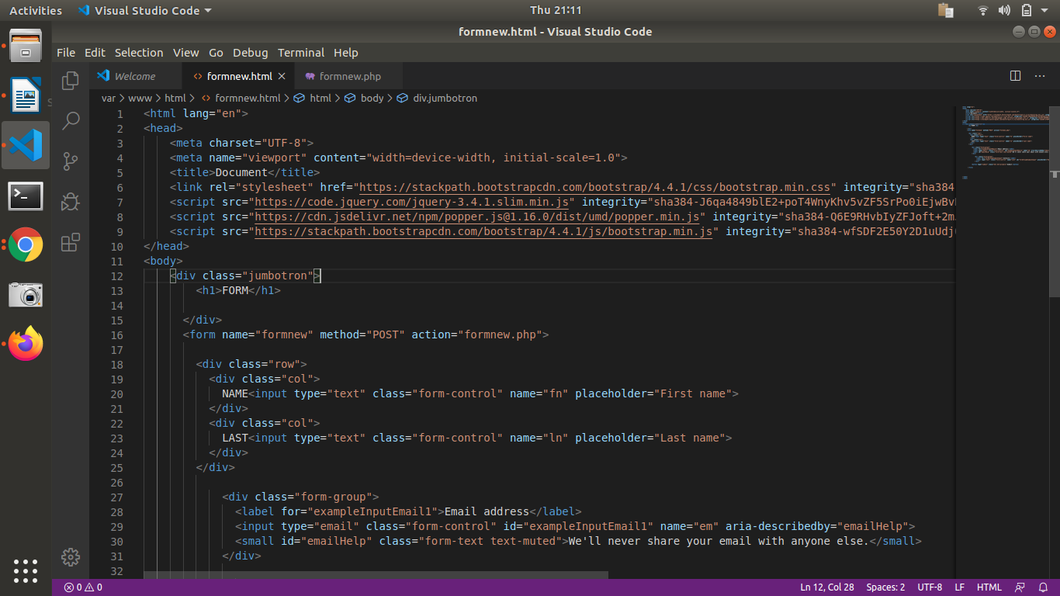

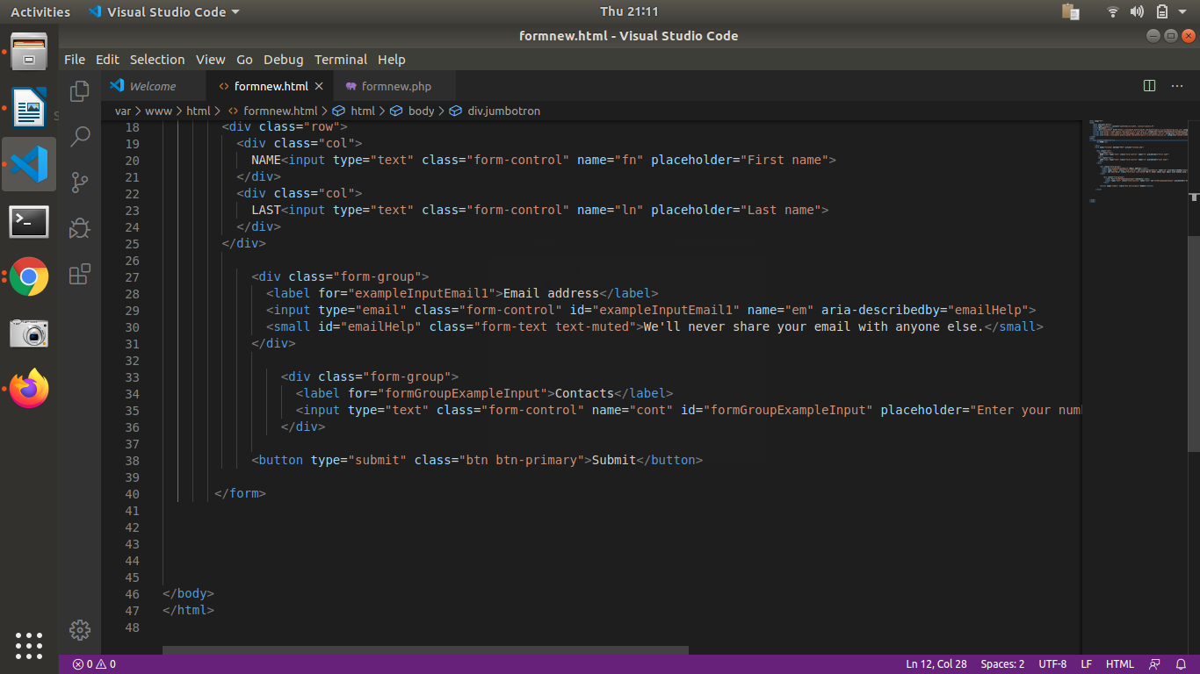

**PHP CODE WITH VALIDATION AND CONNECTION TO SQL DATABASE :**

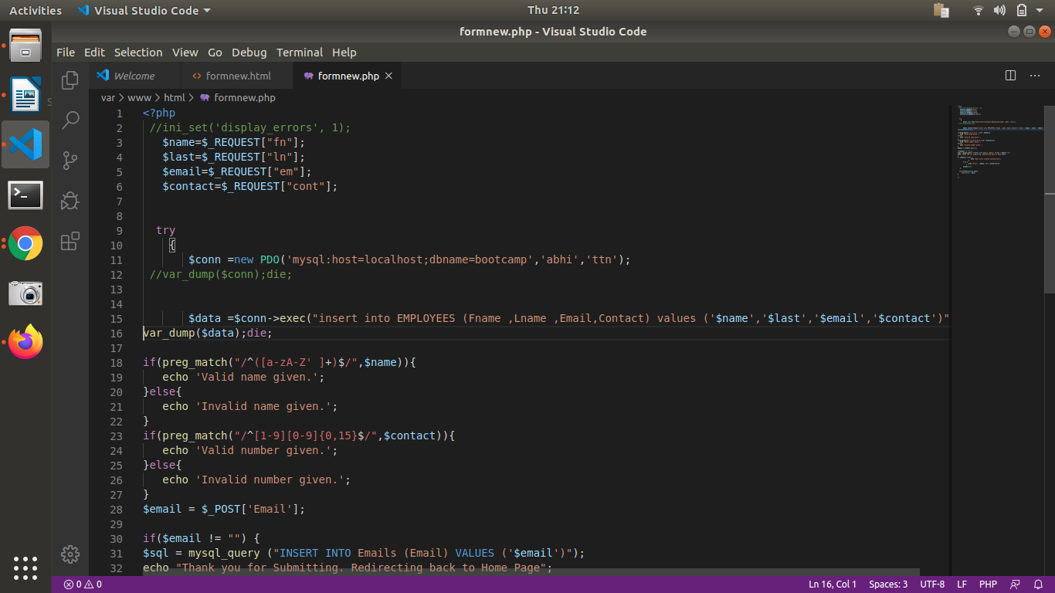

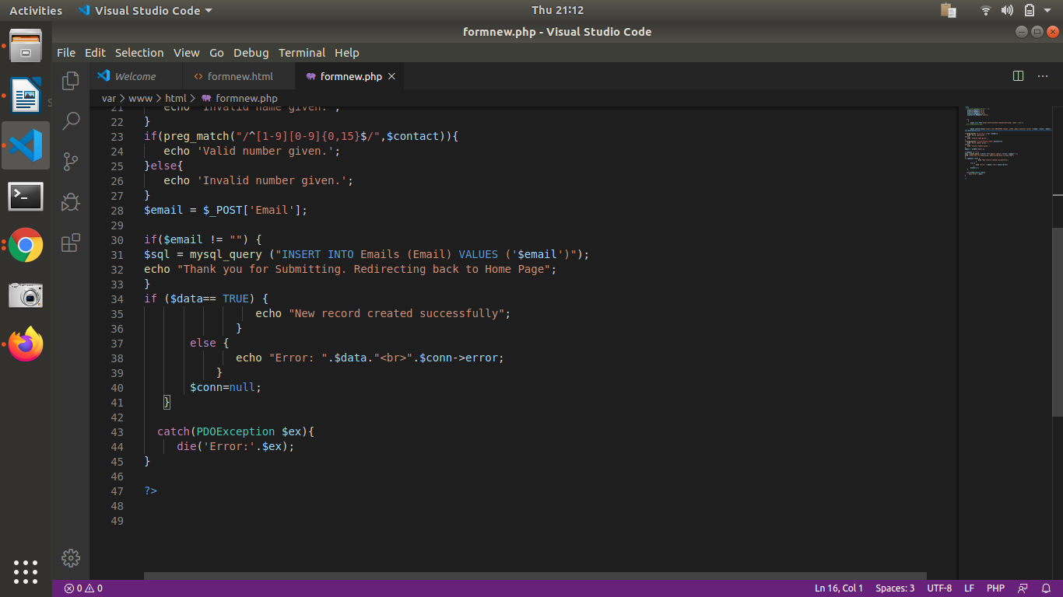

**SCREENSHOT OF THE FORM:**

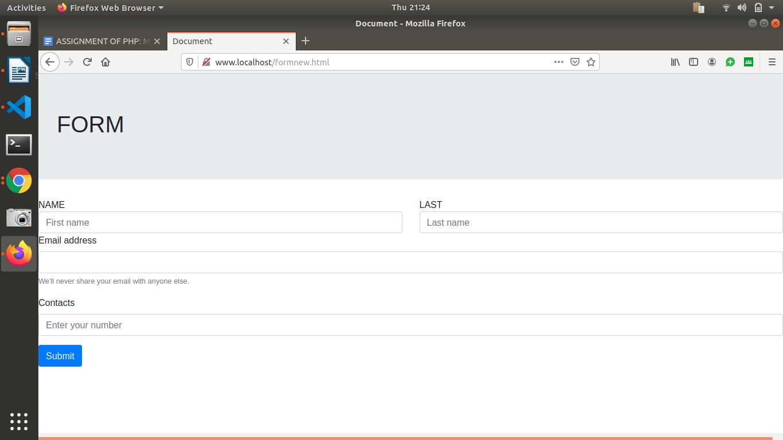

**ENTERING THE FIRST EMPLOYEE DETAILS:**

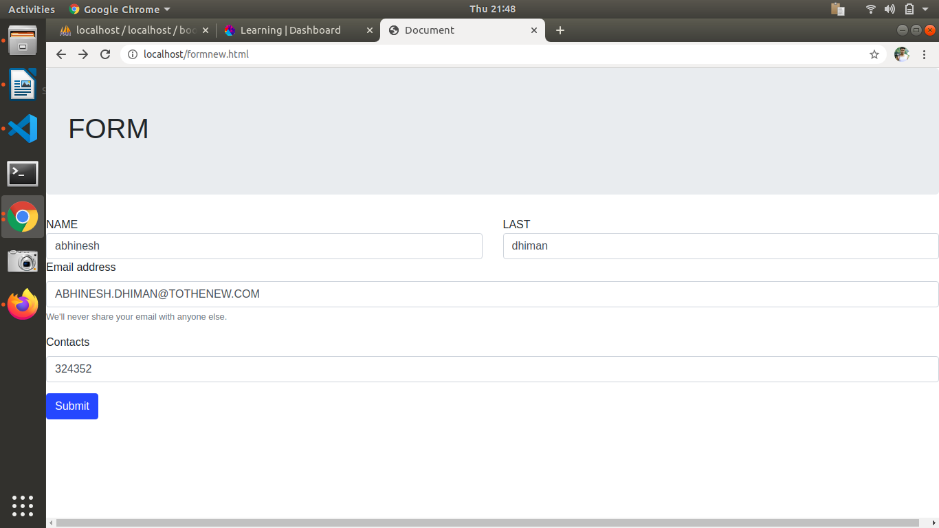

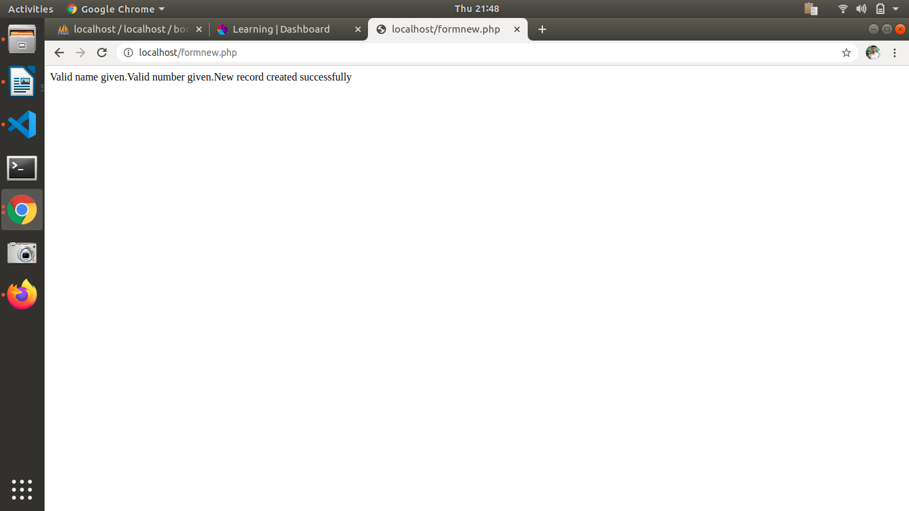

**Database Entry:**

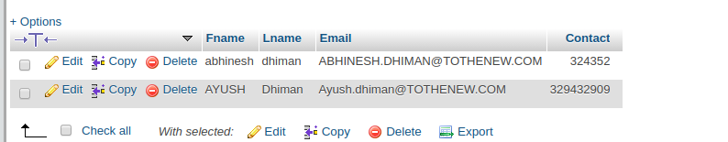

**Simillarly Adding more employees to the table:**

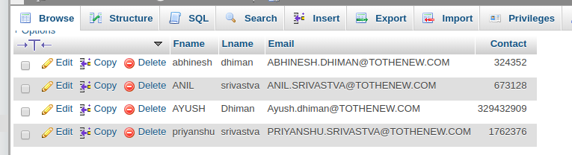

**TRYING to add simmilar emailid of ANIL srivastva to check validation:NO NEW ENTRY DONE BY SAME EMAIL AS SHOWN BELOW**

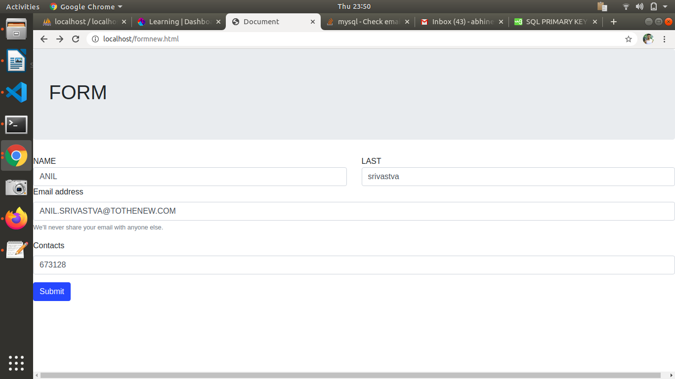

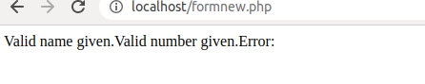

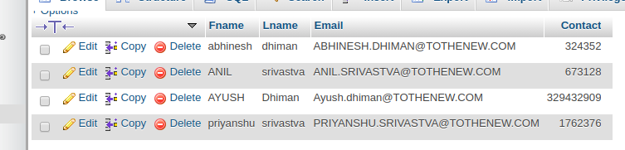

**QUESTION 2:** **Create a form to search records by name, email and contact number. It should show matching results.**

**ANSWER 2:**

**PHP +HTMLCODE :**

**<?php**

**ini_set('display_errors', 1);**

**try{$conn =new PDO('mysql:host=localhost;dbname=bootcamp','abhi','ttn');**

**if ($conn){}**

**else{echo "error";}**

**}**

**catch(PDOException $ex){die('Error:'.$ex);}**

**?>**

**<html lang="en">**

**<head>**

**<meta charset="UTF-8">**

**<meta name="viewport" content="width=device-width, initial-scale=1.0">**

**<title>Document</title>**

**<link rel="stylesheet" href="https://stackpath.bootstrapcdn.com/bootstrap/4.4.1/css/bootstrap.min.css" integrity="sha384-Vkoo8x4CGsO3+Hhxv8T/Q5PaXtkKtu6ug5TOeNV6gBiFeWPGFN9MuhOf23Q9Ifjh" crossorigin="anonymous">**

**<script src="https://code.jquery.com/jquery-3.4.1.slim.min.js" integrity="sha384-J6qa4849blE2+poT4WnyKhv5vZF5SrPo0iEjwBvKU7imGFAV0wwj1yYfoRSJoZ+n" crossorigin="anonymous"></script>**

**<script src="https://cdn.jsdelivr.net/npm/popper.js@1.16.0/dist/umd/popper.min.js" integrity="sha384-Q6E9RHvbIyZFJoft+2mJbHaEWldlvI9IOYy5n3zV9zzTtmI3UksdQRVvoxMfooAo" crossorigin="anonymous"></script>**

**<script src="https://stackpath.bootstrapcdn.com/bootstrap/4.4.1/js/bootstrap.min.js" integrity="sha384-wfSDF2E50Y2D1uUdj0O3uMBJnjuUD4Ih7YwaYd1iqfktj0Uod8GCExl3Og8ifwB6" crossorigin="anonymous"></script>**

**</head>**

**<body>**

**<form method="post">**

**<div class="input-group mb-3">**

**<input type="text" name="name" class="form-control" placeholder="Search">**

**<div class="input-group-append">**

**<input class="btn btn-success" type="submit" value="Name" name="submit">**

**<input class="btn btn-success" type="submit" value="Email" name="email">**

**<input class="btn btn-success" type="submit" value="Contact" name="contact">**

**</div>**

**</div>**

**</form>**

**<?php**

**if(isset($_POST['submit'])){**

**$fname=$_POST['name'];**

**echo $fname;**

**$stmt = $conn->prepare("SELECT * FROM EMPLOYEES where Fname= :fname");**

**$stmt->execute(['fname' => $fname]);**

**$result = $stmt->fetchAll(PDO::FETCH_ASSOC);**

**?>**

**<table>**

**<tr>**

**<th>First Name</th>**

**<th>Last Name</th>**

**<th>Email</th>**

**<th>Contact</th>**

**</tr>**

**<?php**

**foreach($result as $value)**

**{**

**?>**

**<tr>**

**<td><?php echo $value['Fname']; ?></td>**

**<td><?php echo $value['Lname']; ?></td>**

**<td><?php echo $value['Email']; ?></td>**

**<td><?php echo $value['Contact']; ?></td>**

**</tr><br><br>**

**<?php**

**}**

**?>**

**</table>**

**<?php**

**}**

**?>**

**<?php**

**if(isset($_POST['email'])){**

**$fname=$_POST['name'];**

**echo $fname;**

**$stmt = $conn->prepare("SELECT * FROM EMPLOYEES where Email= :fname");**

**$stmt->execute(['fname' => $fname]);**

**$result = $stmt->fetchAll(PDO::FETCH_ASSOC);**

**?>**

**<table>**

**<tr>**

**<th>First Name</th>**

**<th>Last Name</th>**

**<th>Email</th>**

**<th>Contact</th>**

**</tr>**

**<?php**

**foreach($result as $value)**

**{**

**?>**

**<tr>**

**<td><?php echo $value['Fname']; ?></td>**

**<td><?php echo $value['Lname']; ?></td>**

**<td><?php echo $value['Email']; ?></td>**

**<td><?php echo $value['Contact']; ?></td>**

**</tr><br><br>**

**<?php**

**}**

**?>**

**</table>**

**<?php**

**}**

**?>**

**<?php**

**if(isset($_POST['contact'])){**

**$fname=$_POST['name'];**

**echo $fname;**

**$stmt = $conn->prepare("SELECT * FROM EMPLOYEES where Contact= :fname");**

**$stmt->execute(['fname' => $fname]);**

**$result = $stmt->fetchAll(PDO::FETCH_ASSOC);**

**?>**

**<table>**

**<tr>**

**<th>First Name</th>**

**<th>Last Name</th>**

**<th>Email</th>**

**<th>Contact</th>**

**</tr>**

**<?php**

**foreach($result as $value)**

**{**

**?>**

**<tr>**

**<td><?php echo $value['Fname']; ?></td>**

**<td><?php echo $value['Lname']; ?></td>**

**<td><?php echo $value['Email']; ?></td>**

**<td><?php echo $value['Contact']; ?></td>**

**</tr><br><br>**

**<?php**

**}**

**?>**

**</table>**

**<?php**

**}**

**?>**

**</body>**

**</html>**

**SCREENSHOTS:**

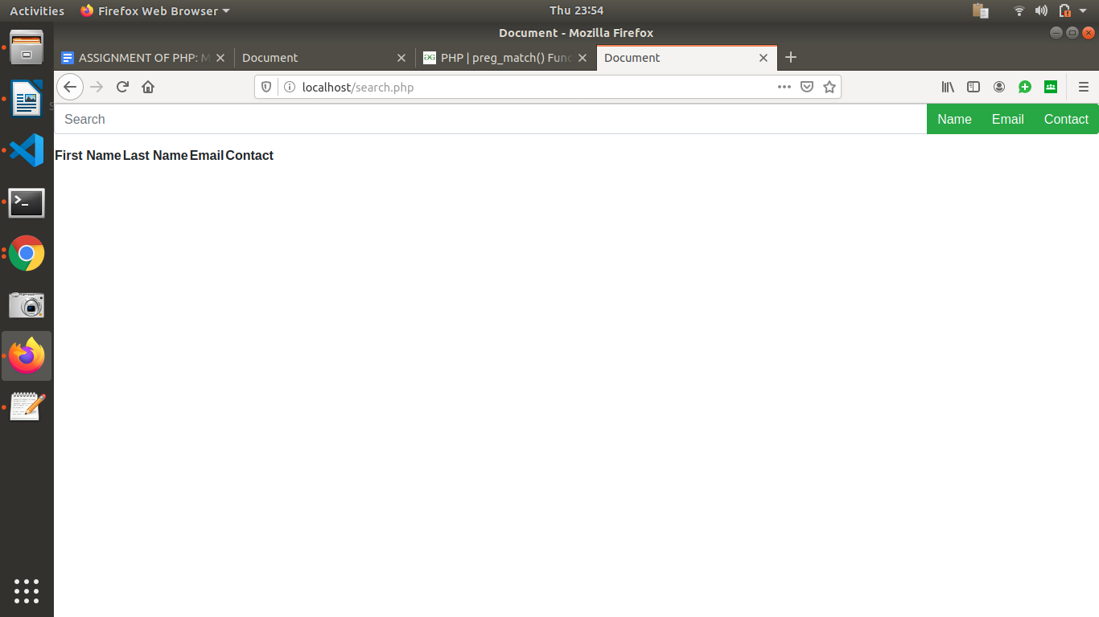

**SEARCH BY NAME :**

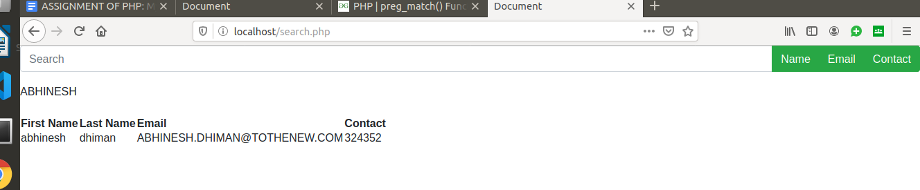

**SEARCH BY EMAIL:**

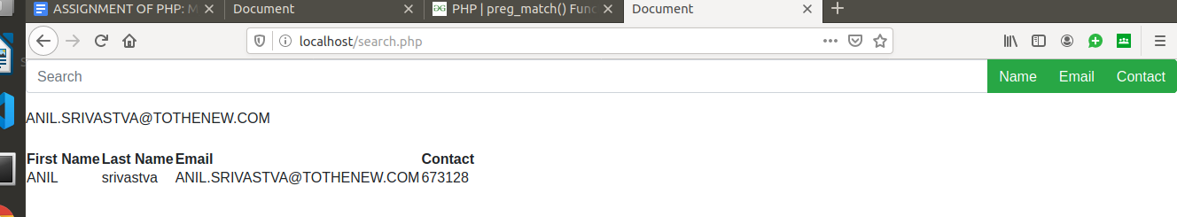

**SEARCH BY CONTACT:**

